**QSMART – LB CCA REPLACEMENT**

**PROCEDURE**

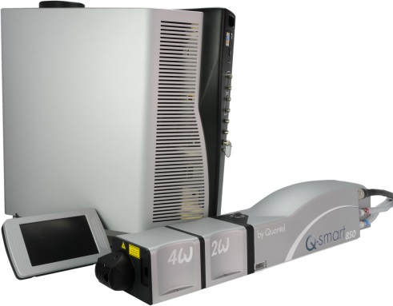

**Toolkit:**

Allen keys

**System**: QSMART

|  |  |  |  |  |  |  |  |  |  |
| --- | --- | --- | --- | --- | --- | --- | --- | --- | --- |
| |  |  | | --- | --- | | 4/300/1036D | **Q-SMART LB CCA** | | | | |  |  |  |  |
|  |  |  |  |
|  |

**Purpose**: This document details how to change the LB Card

|  |  |  |
| --- | --- | --- |
| Revision | date | modification |
| Initial issue | July 4, 2014 |  |
|  |  |  |
|  |  |  |
|  |  |  |

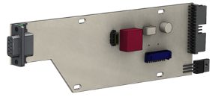

# DISASSEMBLING

* Turn the system off
* Disconnect cables and water hoses from the side of the laser head
* Remove the laser head cover.
* Remove the side plate (7 BHC 3x6)

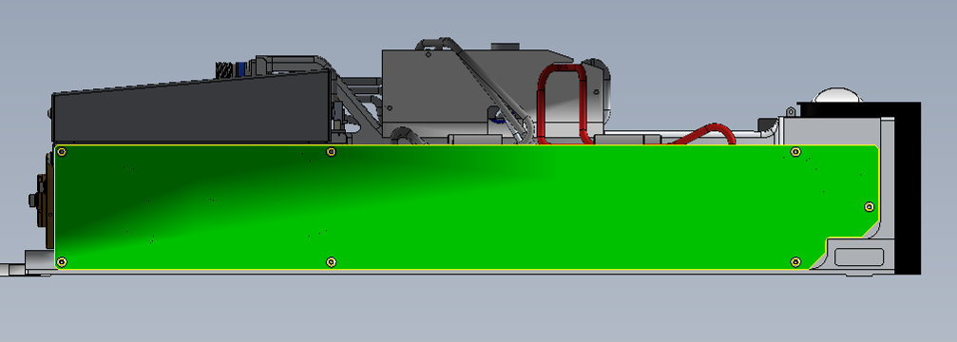

* Remove the two UNC 4-40 long ¼ 3/E13/0601 screws on the front side

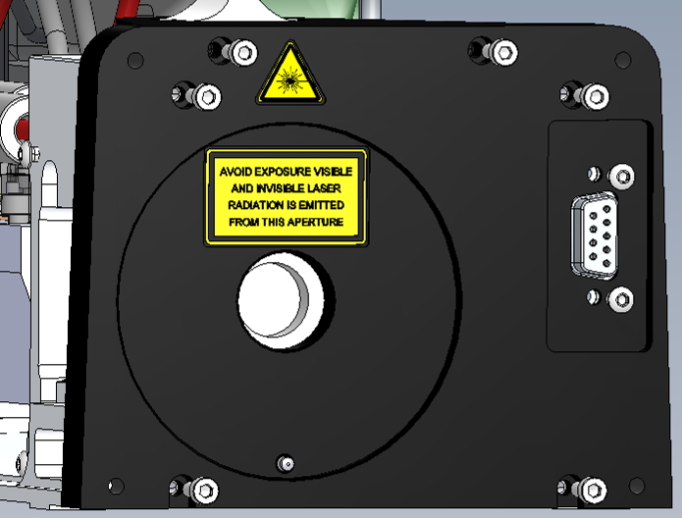

Connector attachment face avant

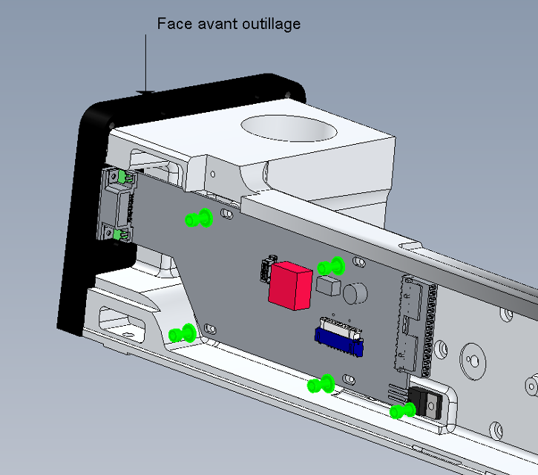

Transistor

* Remove CHC (3x6) screw + ZU3 washer of the transistor.
* Disconnect the LED cable from the LB card (J3). Remove the 4 screws CHC 3x8 + 4 M3U washers

# IMPLEMENTATION OF THE CARD AND LB TRANSISTOR

|  |  |  |
| --- | --- | --- |
| 5.00 | V/CHC-M0310A4 | CHC3X10 SCREW |
| 4.00 | R-MU--D03--A2 | MU3 WASHER |
| 1.00 | R-ZU--D03--A2 | ZU3 WASHER |

 Pass the LED card wires under the LB card 4/300/1036 (refer to the picture).

Transistor

* Fasten with 4 CHC 3x6 screws + 4 M3U washers without tightening
* Connect the LED cable on the LB card (J3).
* Install the LB card connector on the front and tighten each screw.
* Fasten the transistor of the card with a CHC 3x6 screw + ZU3 washer.
* Weld the three pins of the transistor.

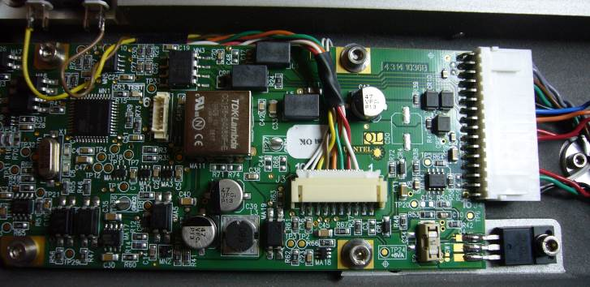

Thermistor wire



Screw the 2 screws 4-40 UNC long 3/E13/0601 ¼ on the front panel

Fixation connecteur face avant

* Close the Laser head and put warranty stickers   
  *Refer to "LH-Warranty Labels"*